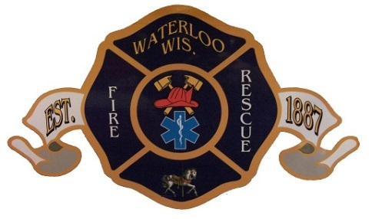WATERLOO FIRE & RESCUE

900 INDUSTRIAL LANE

WATERLOO, WISCONSIN 53594

City Of Waterloo Position Description

This job description has been prepared to assist in the evaluation of various classes of responsibilities, skills, and working conditions. It indicates the kinds of tasks and levels of work difficulty generally required of positions given this job. The principal duties and responsibilities enumerated are all essential functions except for supplemental duties and responsibilities. Supplemental duties are described beginning with the work “May.” This job description is not intended to limit or modify the right of any supervisor to assign, direct and control the work of employees. Nothing contained herein is intended or shall be constructed to create constitute a contract of employment between and employee or group of employees and the City. The City retains and reserves any and all rights to change, modify, amend, add to, or delete from any section of the description as it deems, in its judgement, to be proper.

**Open Date**: December 1, 2024 - **Closing Date** January 31, 2025 **Interviews** February 2025

**Title:** Firefighter-AEMT (Full-Time) **Department:** Fire Rescue **FSLA:** Non-exempt

**General Summary:**

Responds to fire alarms, medical emergencies and other calls to protect life and property. Participates in fire prevention, training, and station, equipment and apparatus maintenance and variety of other assigned duties associated with fire and rescue. Work involves risk and hazardous exposure.

**Reporting Relations:**

Works under direct supervision and in accordance with department policies, practices, procedures, rules and regulations. Regularly interacts with public contacts during emergency calls and through public relation events.

**Specific Accountabilities:**

1. Responds to fire or other emergencies; accesses situation, takes mitigation actions, and rescues persons from danger as required.
2. Fights fire or takes actions to mitigate other situations such as natural disasters, hazardous materials releases, or other dangerous situations.
3. Identifies persons requiring immediate care, provide advanced, prehospital medical services and transports victims for further medical care.
4. Participates in training, education, and drills which include firefighting and medical skills and techniques, and proper use of equipment and related tools.
5. Assists fire inspectors with fire prevention inspection, perform building pre-planning for fire and other emergencies, assist the public providing safely related services, tours, public presentations or events to promote safety consciousness.
6. Makes inspections of apparatus and equipment; assures that all equipment and apparatus is always in a state of readiness and notifies supervisor of defects; performs cleaning and maintenance tasks in and about the station.
7. Performs routine tasks such as report writing, record keeping, data entry, supplies maintenance, phoning and copying.
8. Represents the department with dedication, respect, courage, innovation, professionalism, and accountability in all relationships with citizens, community and professional organizations, other fire agencies, city departments, count state and federal agencies and other service organizations.
9. Performs other related duties as assigned.

**Required knowledge, skills and abilities:**

At time of hire, graduate from high school (or H.S.E.D) equivalent) and possess a valid Wisconsin Driver’s License, AEMT Licensed and Firefighter I certified. Within one year of hire be NIMS 100, 200, and 700. Have an equivalent combination of education and experience which provides the following knowledge, skills and abilities:

Knowledge in:

* Firefighting, rescue techniques, fire prevention, and emergency medical services methods, techniques and practices.
* Computer applications involving word processing, data entry and/or standard report generation.
* Regulations, ordinances, and laws regarding a firefighter/emergency services department.
* The geography of the city, surrounding area and hydrant locations

Skills in:

* Techniques for dealing with a variety of individuals from various socioeconomic, ethnic and cultural backgrounds, often in situations which may be stressful.
* The ability to understand, follow and effectively carry out instructions.
* Maintaining safety precautions in performance of work.
* Evaluating patient’s conditions and properly render emergency medical care including the administration of emergency medications.
* Preparing and composing reports and records on activities performed.

Ability to:

* Sustain physical effort involving performance of duties in situations of personal danger with exposure to all types of weather conditions and heights.
* Lift and carry 140 pounds, sit, stoop, crawl, bend, climb and twist while performing the essential functions of this job.
* Read and understand policies, rules, instructions, and written material pertaining to fire and rescue operations.
* Exercise judgement during hazardous circumstances.
* Act quickly and effectively during emergencies.
* Maintaining AEMT license, it is a condition of employment.
* Establish and maintain effective working relationships with those contacted in the course of work.

Please visit our website @ [www.waterloofd.com/services---employment.html](http://www.waterloofd.com/services---employment.html)

for employment application and Department overview.